**Wireframes and Functions – 1.1v**

1. Customer login
   1. C_home (including Testimonials) – All in one – slide with the navigation bar
      1. [Chandani Bandara Salons - Maharagama - No:133/1, Highlevel Road - Maharagama | Fresha](https://www.fresha.com/a/chandani-bandara-salons-maharagama-maharagama-no-133-1-highlevel-road-xmtyk26z)
      2. Home
         1. Search on top
            1. 
         2. One page
            1. 
      3. Product/services page – alter this one
         1. 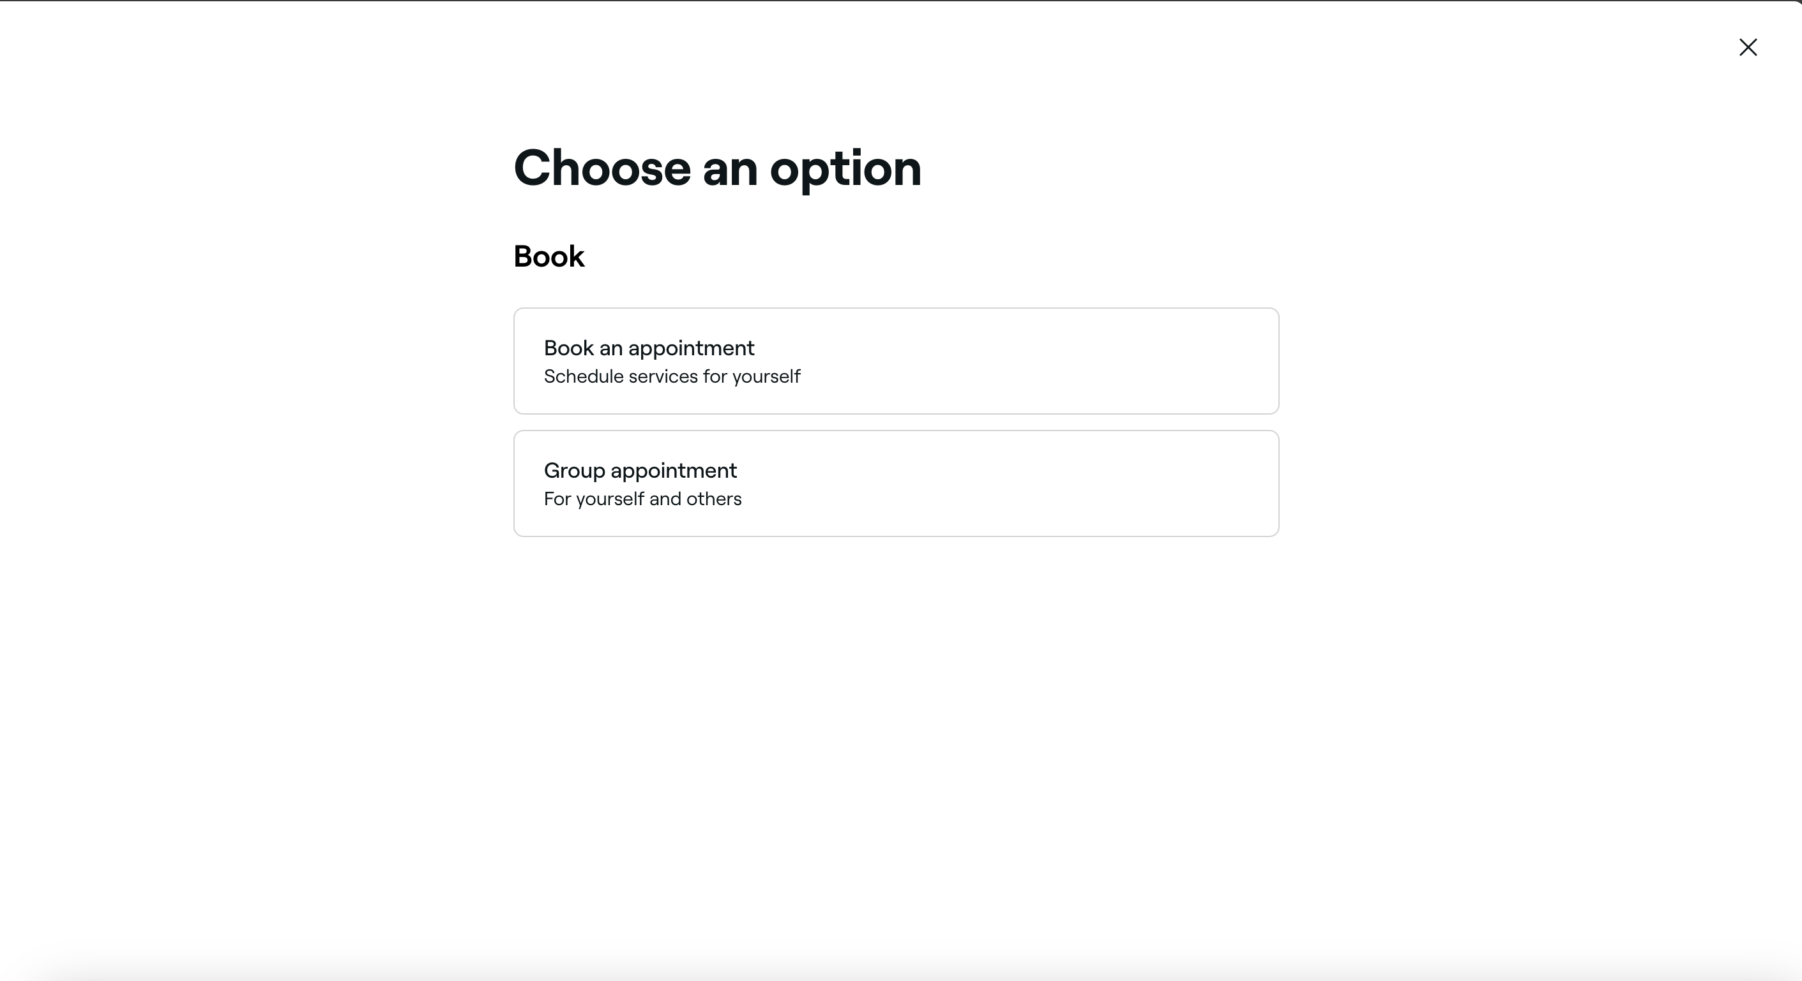
      4. Add to cart page/side by side
         1. 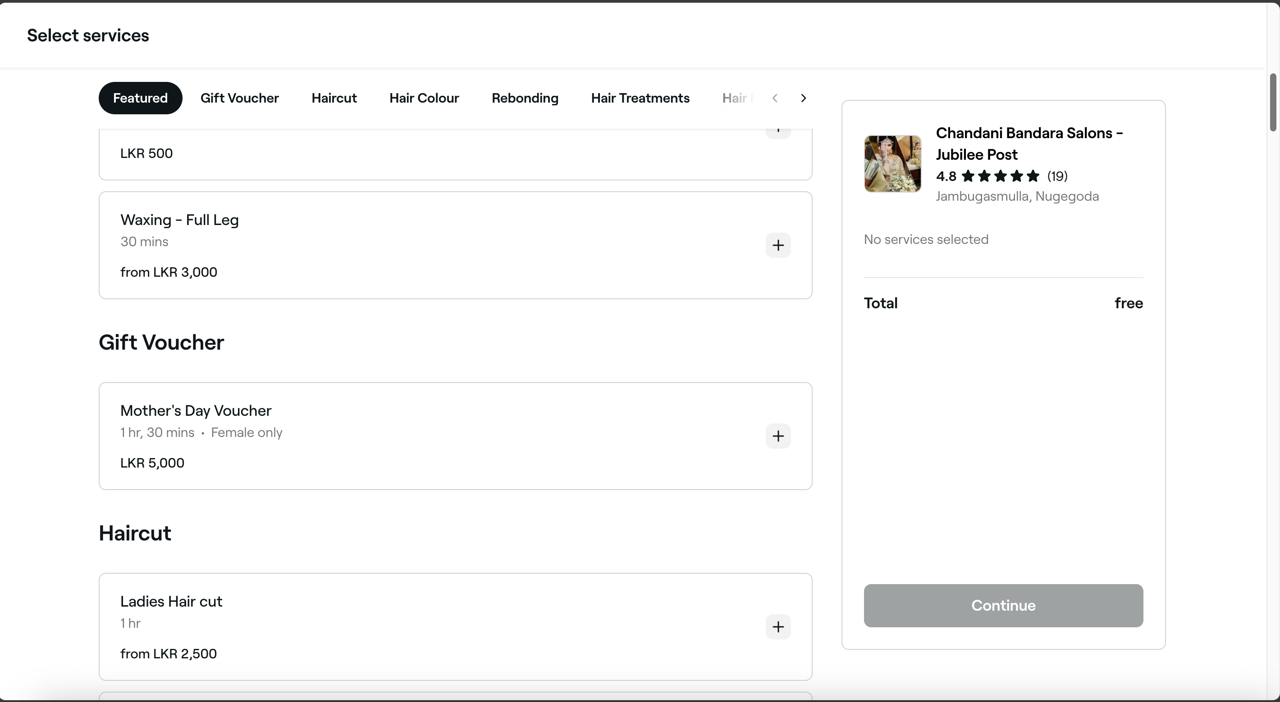
      5. Professional- select
      6. Time – select
      7. Review and payment selecting page
         1. [Payment logic ]
      8. Appointment finalize and reviewing page(all appointments should be here)
         1. 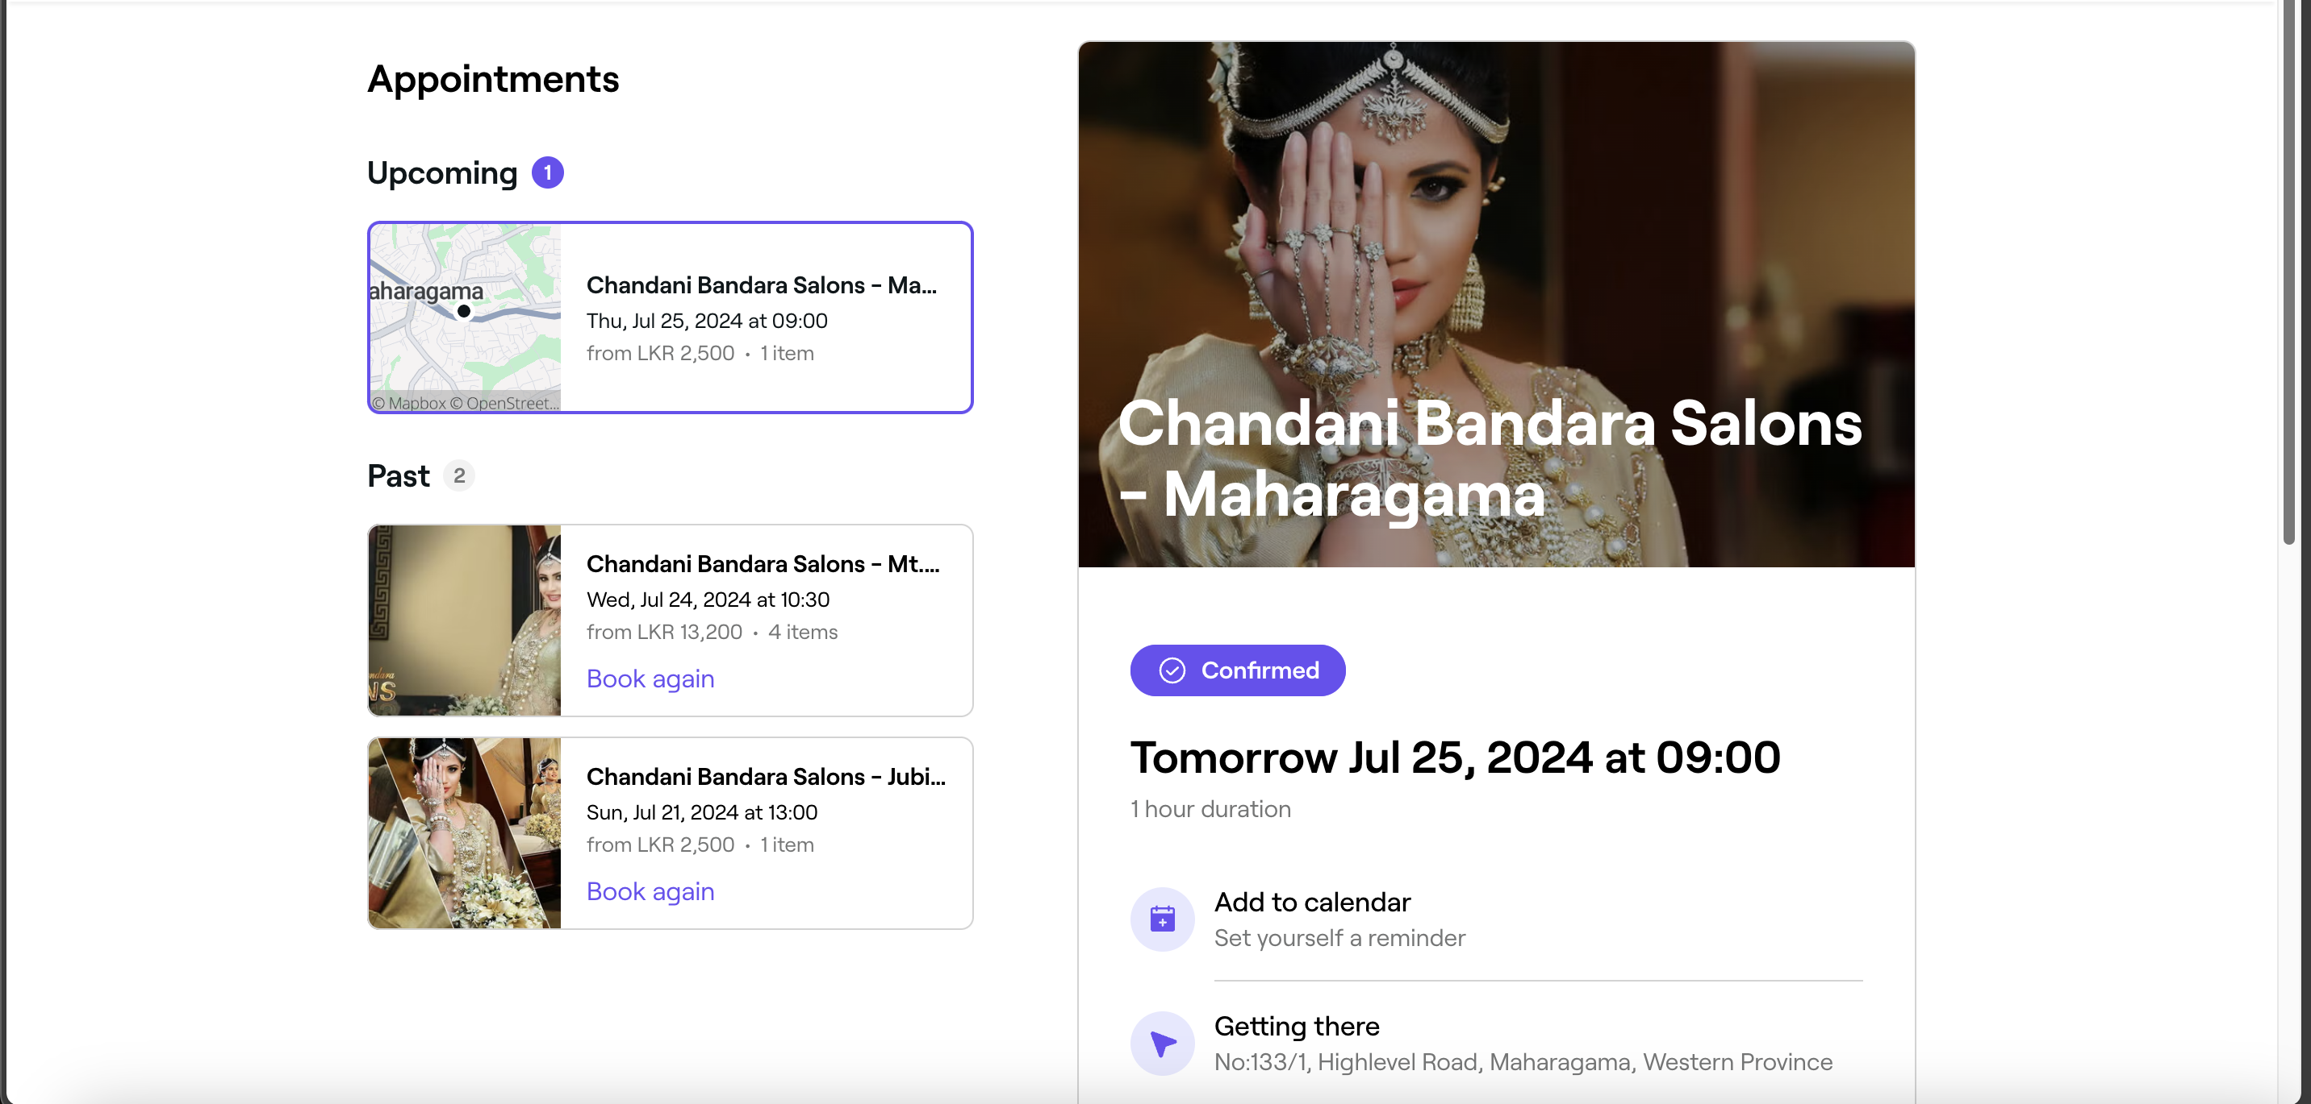
         2. 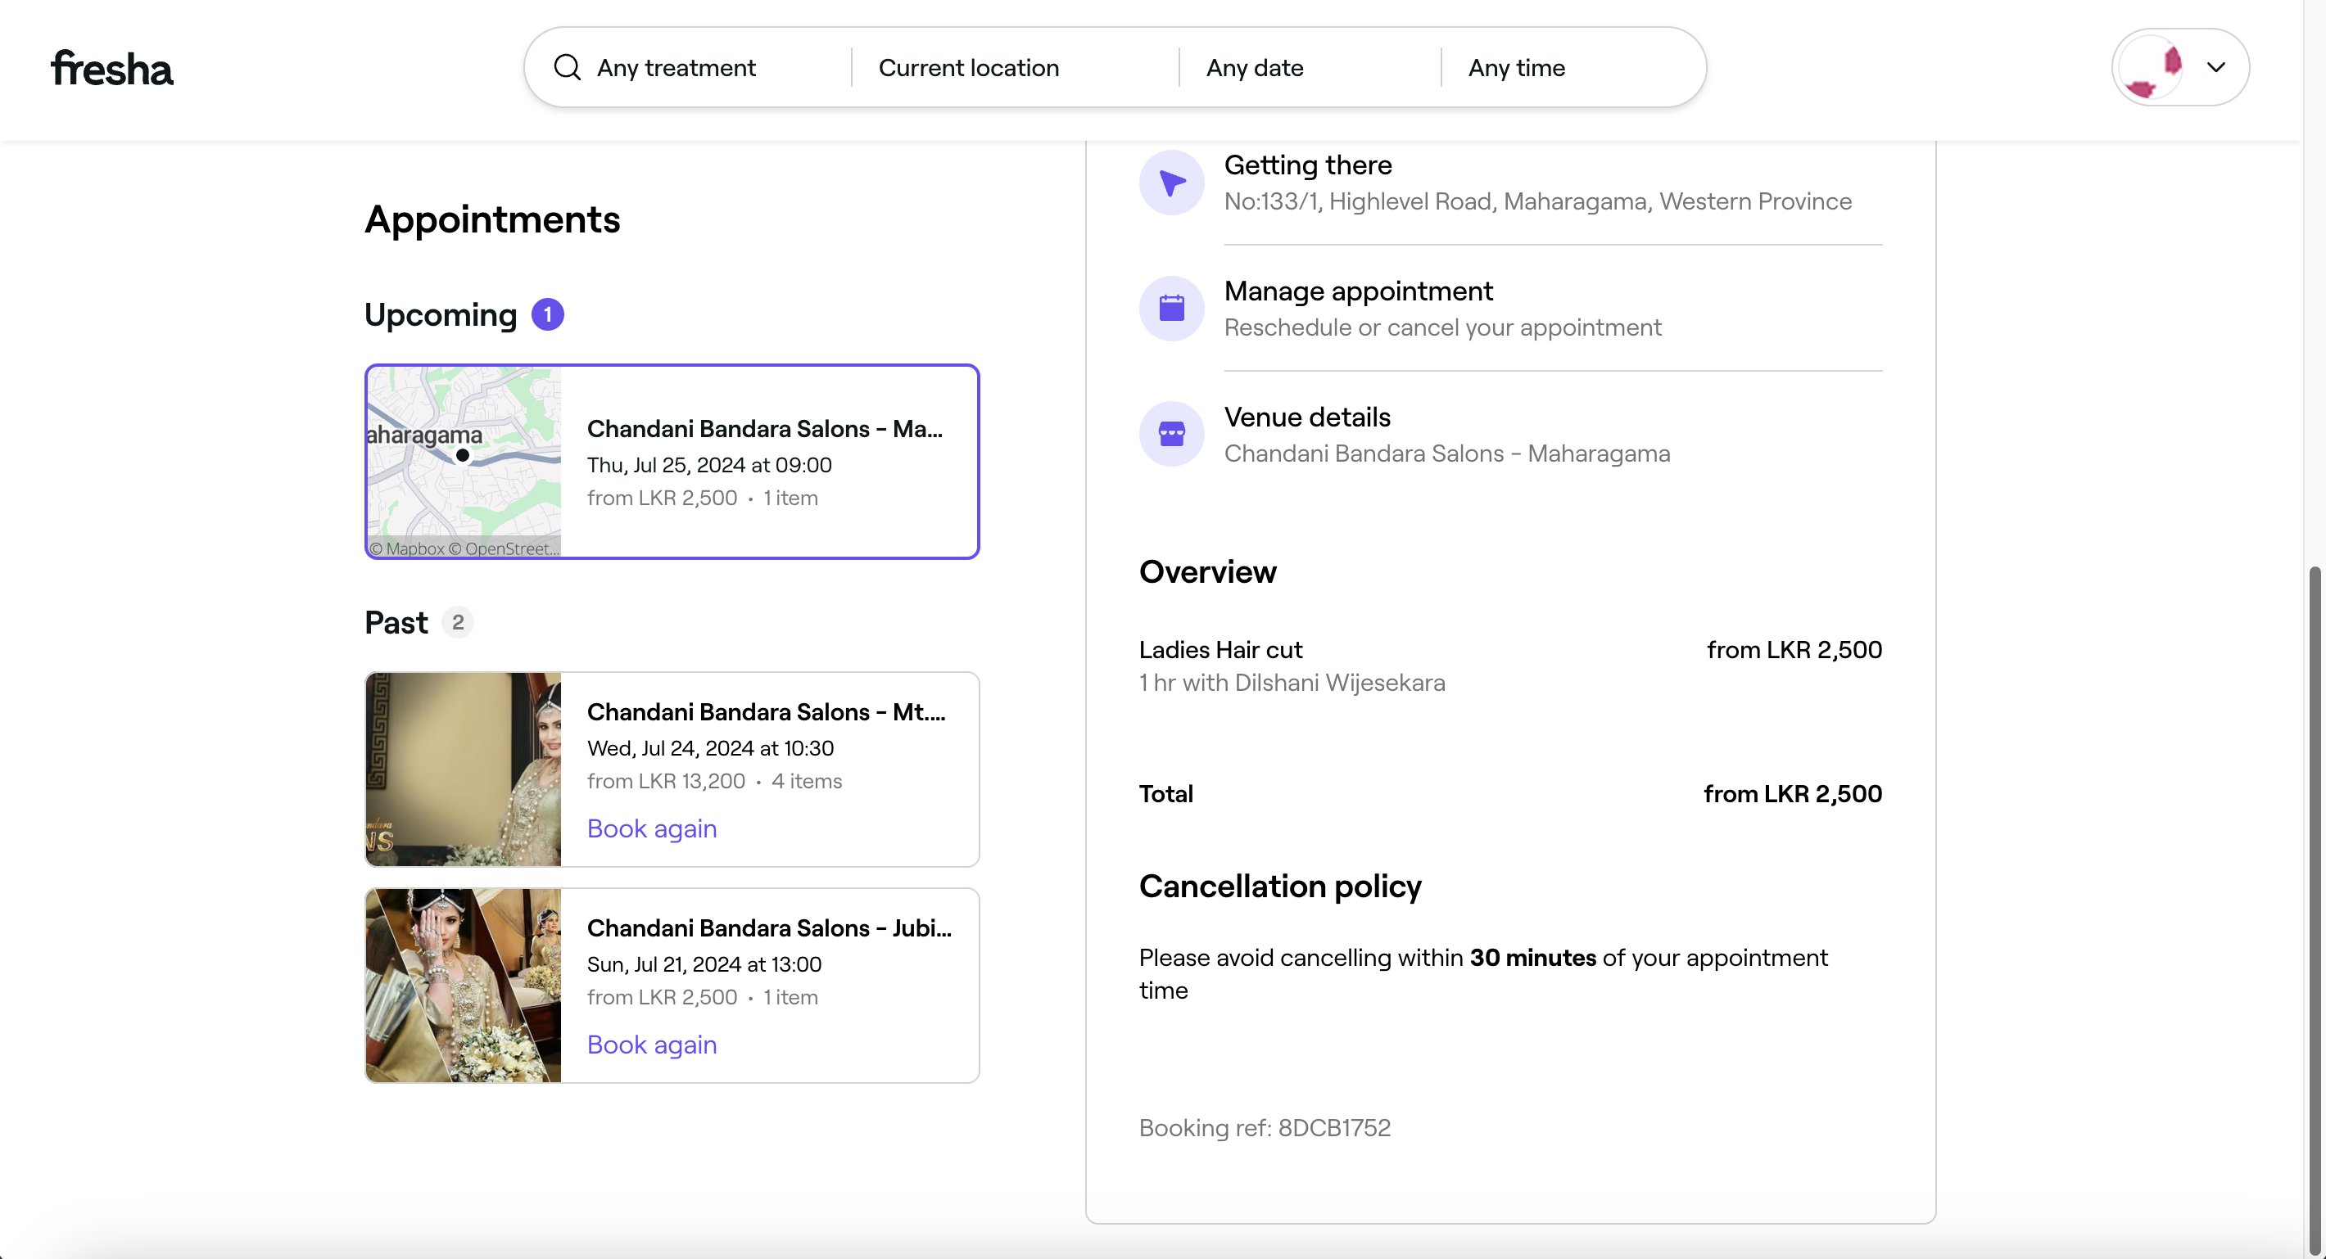
2. Admin login
   1. Admin_home
      1. 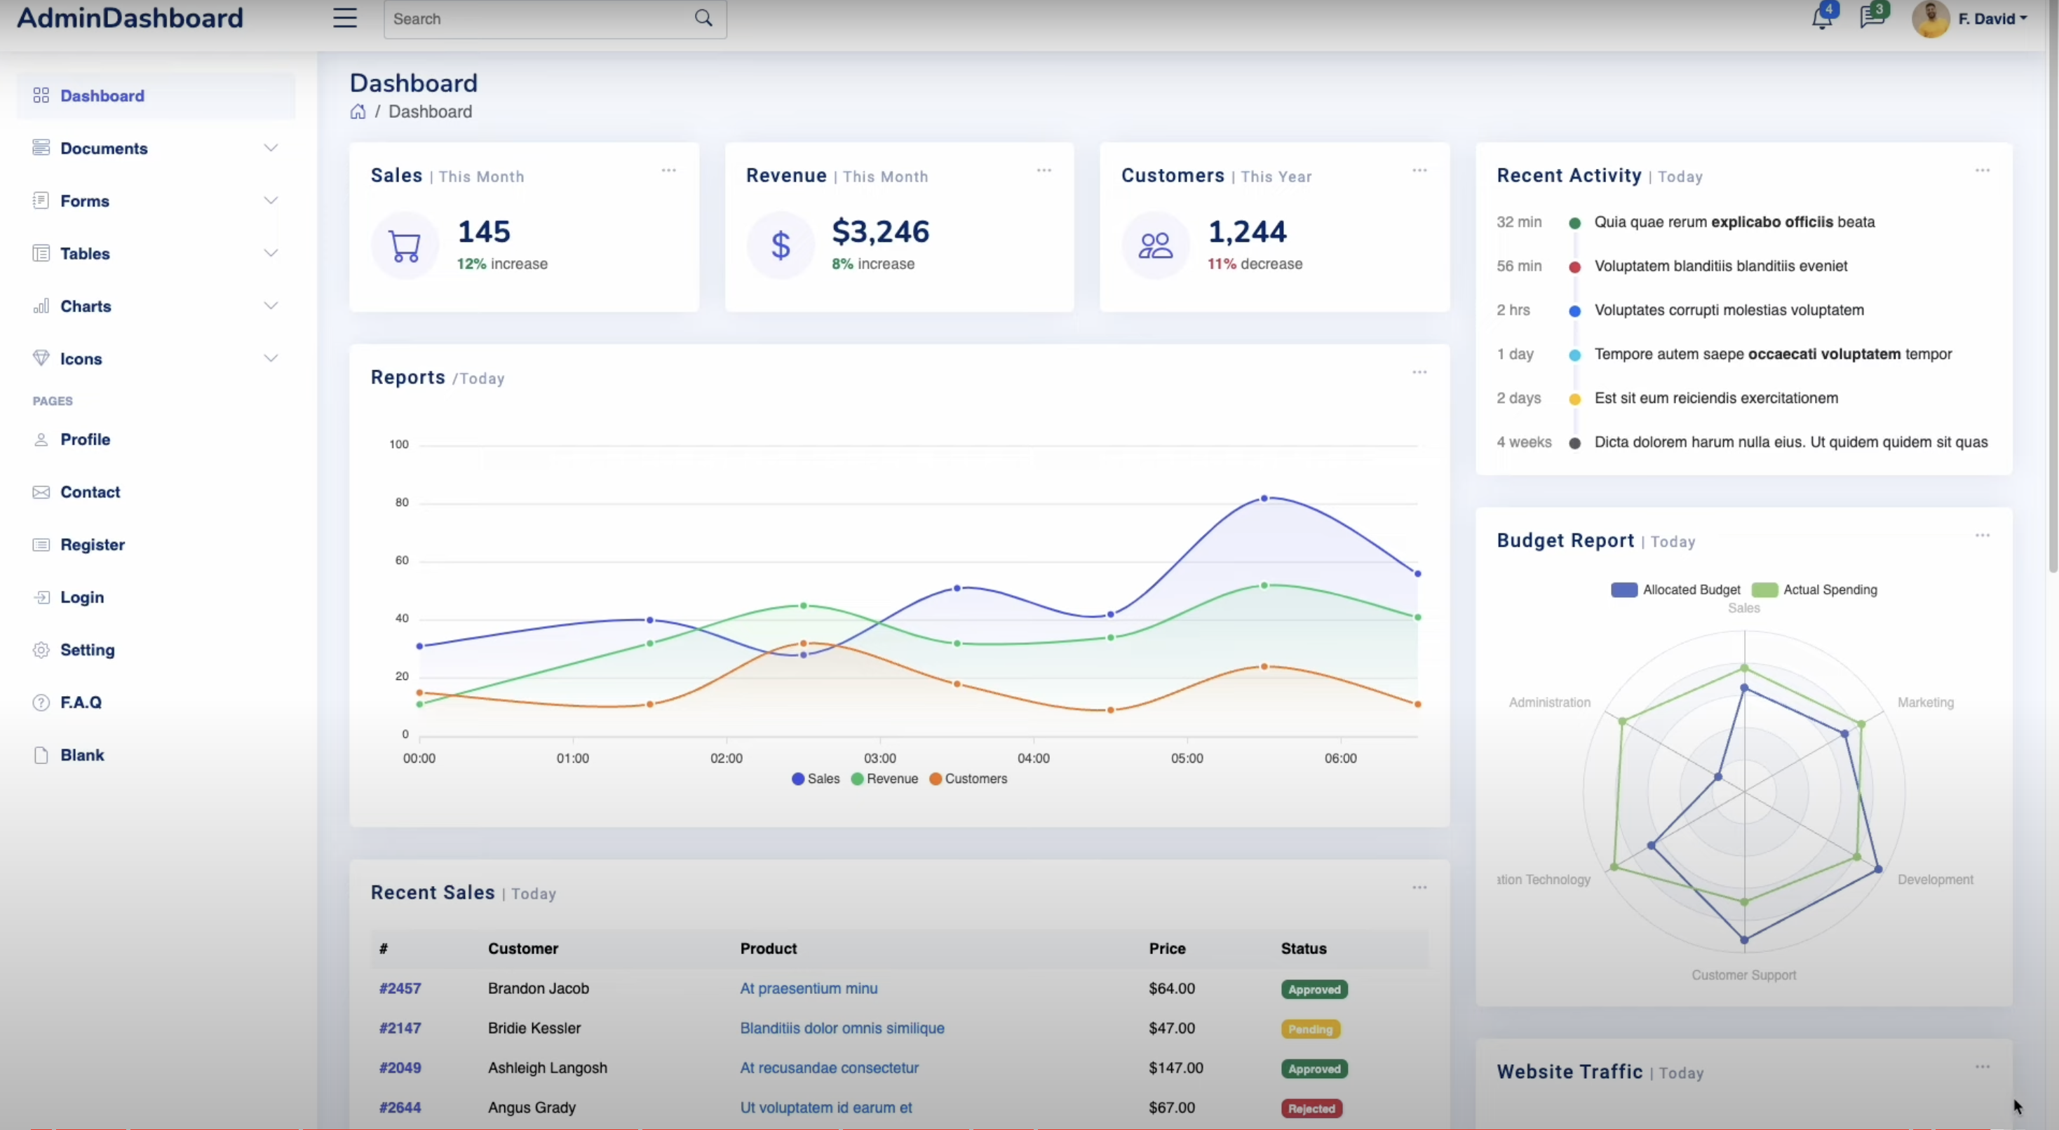
         1. Include- sales, revenue, customers(and their increments)
         2. Relevant charts
   2. Profile
   3. Charts and tables page- sales and revenue
   4. Staff and customer handling page – edit/delete/(staff-add)
   5. Inventory management
   6. Products and services management
   7. Appointment handling
   8. Staff payments and bonuses handling
   9. Staff attendance
3. Employee login
   1. Emp_home
   2. Emp profile update
   3. Inventory management (inv. Manger-opt)
   4. Leaves
   5. Salary and history
   6. Own appointments (cancellation)

Logics to think

* + - 1. Payment
      2. Appointment

Functions/CRUDS

1. Logins, registrations – pamuditha
2. inventory management - navodya
3. Testimonials- amalie
4. services/ items -ishan
5. staff management – dasun
   1. leaves
   2. attendance
6. appointments(on confirmation)- anuththara
7. cart - sasanka
8. customer support – Shamika akka

#Current version 1.0v – there’s no online payment option- only pay at venue

